**Servo Motor and It’s Useage**

**Description**: Servo motor is a motor which can rotate at 0 to 180 degree and again 180 to 0 degree. We can rotate servo motor as much rotetion as we want with the help of PWM pin in Arduino board.

**Servo Motor :**

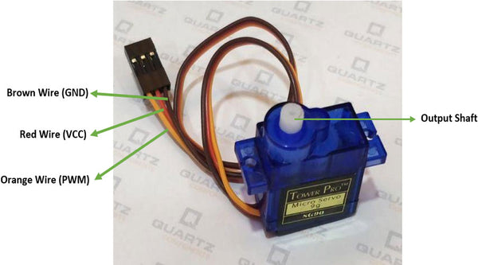

**Connection**:

* RED wire connected to 5V .
* Brown Wire connected to GND(Ground).
* Orange Wire connected to any PWM pin of the Arduino board.

**Circuit Diagram:**

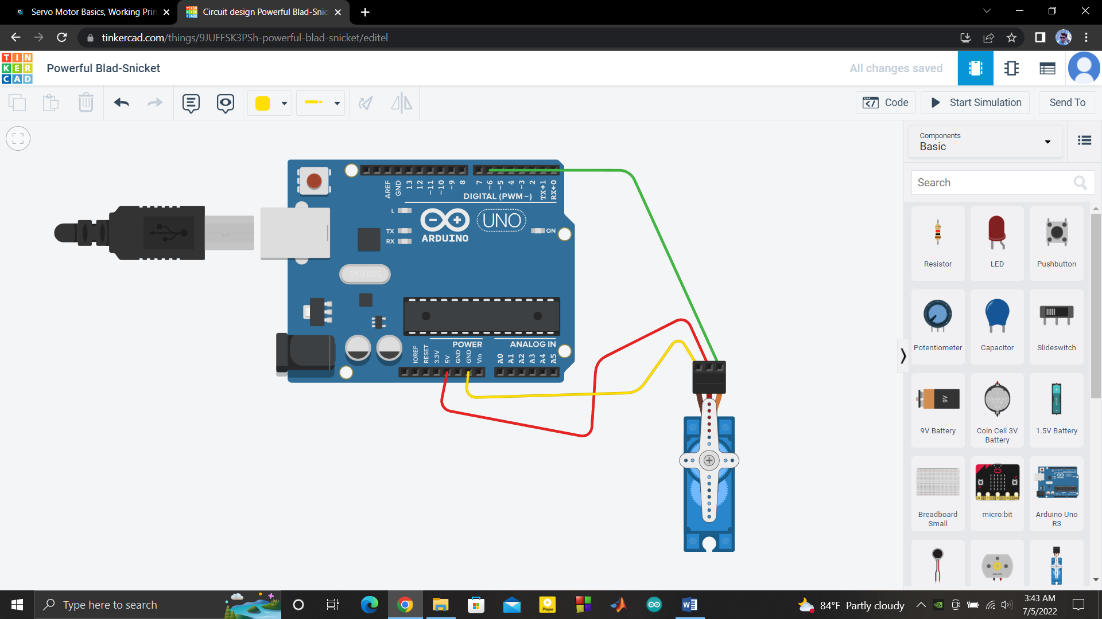

**CODE:**

|  |
| --- |
| #include<Servo.h> Servo myservo; int p;   void setup() {   // put your setup code here, to run once: myservo.attach(6); // arduino’s 6 pin connected to servo’s output pin }  void loop() {   // put your main code here, to run repeatedly:   myservo.write(180);   delay(3000);   myservo.write(0);   delay(3000); } |